ISA invites Applications on
2019 “Global SSL Showcase Top100” Awards

Like each year, the Global SSL Showcase Top100 (TOP100) is now open for application.

The award of TOP100 has been successfully launched in 2012 and 73 extraordinary and influential SSL showcases worldwide have been selected as the winners till now.
TOP100 aims to recommend and manifest the best SSL application projects worldwide by demonstrating the SSL R&D achievements, the application of technology innovation, as well as the comprehensive results of best design, reliable products and best installation to promote the characteristics and advantages of SSL, and help people acquire more feel and experiences, and increase the influence of SSL to speed up the promotion and application of SSL in depth and width around the world.
Sign up TOP100, companies can presents their exquisite design, or reliable products, or high quality installation, improve their global visibility and influence, and add credibility for the development of the companies to open up broader markets.
To continue the meaningful work and provide more added valuable service to our members and the SSL industry, TOP100 2019 is now open for application.
Application requirements:
- Any organization in SSL industry worldwide is eligible to apply.
- The applied project (s) shall be completed and accepted before May 10, 2019.

Jury evaluation:

Secretariat of ISA collects and submits applications to the jury panel, which consists of several highly experienced experts and professionals from around the world that specialize in SSL design, engineering, technology, production and SSL R&D. The jury panel will judge the applications according to the Terms of Reference & Rules of Procedure of this award.

Release and publicity:

The winners of the award will be publicized and promoted by ISA in printed book and electronic version to the global SSL industry, relevant national government agencies, R&D organizations, application departments, procurement groups, and international organizations, etc..
The applications will be collected from several types as shown below, and one project can only select one type.
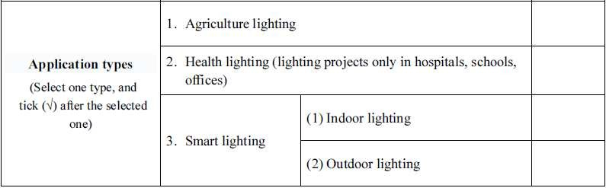

Please submit your applications before 30th May 2019 at ELCOMA office and do not to miss the opportunity of demonstrating your projects to the world.
ELCOMA will have a preliminary screen on the applications and then submit to ISA. Those who fit the required entries will be given to the Jury Panel comprised of highly experienced experts for their evaluation. The successful applications (winners) will be announced and presented to the public at ISA General Assembly in October or November, 2019 at China.

The necessary form can be provided on request by Ms. Nikita Gupta, Contact No. 011-41556644 or Email: nikita@elcomaindia.com. The completed applications along with high pixel photographs can also be submitted to Ms. Nikita Gupta.

